ECA0302 – SIGNALS AND SYSTEMS
NAME: RAGAVARSHINI R
REG.NO: 192512027
CO3 - EXP –(15,16)
To formulate a continuous-time LTI system from a differential equation, obtain its transfer function under zero initial conditions, simulate impulse and step responses, and relate the system poles to its transient behaviour and stability.

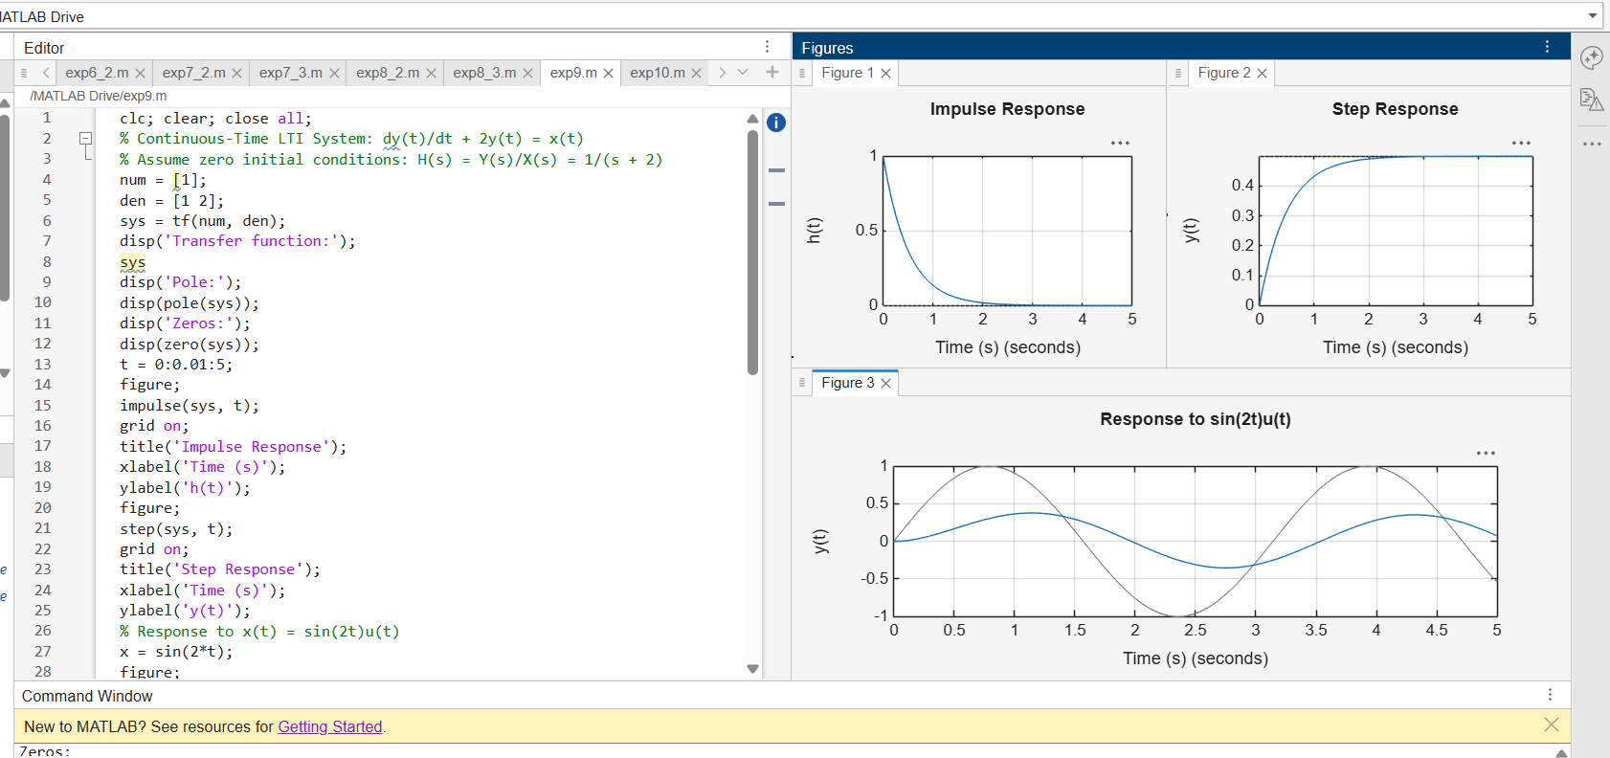
To distinguish the responses produced by initial stored energy and external excitation, obtain the impulse response of a continuous-time LTI system, and verify that the total response is the sum of the zero-input and zero-state responses, with the zero-state response also obtained through convolution.
